**Handout: Jupyter Tips**

1. Keyboard Shortcuts – Help 🡪 Keyboard Shortcuts

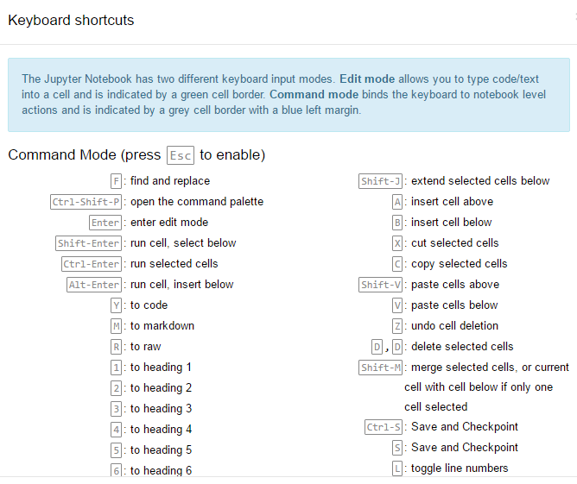

* Getting help. As easy as using ?
  + Try ?str.replace
  + ?pandas.read_csv
* Plotting Inline
  + %matplotlib inline

Will render your plots in the notebook itself. Very handy.

* Try **%lsmagic**
* *# By adding a semicolon at the end, the output is suppressed.*
  + plt**.**hist(x);
* You can share your iPython notebook as HTML or PDF
  + File 🡪 Download as …